What ends up at the sewage treatment plant? (Years 3 and 4)
  - Lesson plan

Introduction
Victorian Curriculum F–10 links:
Science
Levels 3 and 4
Science Understanding
Science as a Human Endeavour
Science knowledge helps people to understand the effects of their actions
Chemical sciences
Objects are made of materials that have observable properties
Earth and space sciences
Earth’s resources are used in a variety of ways
Students gain an understanding about the advanced sewage treatment processes used by Melbourne Water. They also learn about Melbourne’s sewerage system.

For information about schools tours of the Western Treatment Plant, go to Visit the Western Treatment Plant at <http://www.melbournewater.com.au/getinvolved/education/programs/WTPtours/Pages/Visit-the-Western-Treatment-Plant.aspx >

Activity 1: Down the drain in my house
Students explore how different household may end up in the sewage at the sewage treatment plant and conduct a home audit of sewage that enters the sewerage system from their home.

Activity 2: Sewage, sewerage and the sewage treatment plant
Students create a social message on ‘What should or should not be put into the sewerage system’ and develop a visual flow chart of the sewerage system from home to the sewage treatment plant.

Activity 3: The sewage treatment plant and my family
Students create a flow chart that shows how their home connects to the local sewage treatment plant.

Activity 1: Down the drain in my house
Students identify the different types of household items produced in different rooms of their home that may end up in sewage at the sewage treatment plant.

Duration
Two double sessions

Activity steps
- Explain to students that everything that goes down the kitchen, laundry and bathroom drains, as well as what you flush down the toilet is called ‘sewage’ (or wastewater). Make the point that a lot of water ends up as sewage.
- Pose the question, ‘What do we get rid of from our home that might end up as sewage?’
- Draw and label a simple plan of a house on the whiteboard, ensuring that the kitchen, bathroom, toilet and laundry are evident. Move from room to room, asking students to identify items that come from each room that may end up as sewage. List these on the board.
Note: an important part of this initial discussion is to focus on the idea that the items need not be solid, for example, the water and detergents from the dishwasher and washing machine, or cooking oil. Prompt students to think of these types of items as well as the more familiar. See <http://www.melbournewater.com.au/getinvolved/protecttheenvironment/Pages/Help-us-keep-sewers-clean.aspx> for a list of household items.
- Ask students to draw and label a plan of their home, using the plan on the whiteboard as a guide. In each room, students draw where the sewage is produced, for example, the shower in the bathroom; the toilet; the sink and dishwasher in kitchen; the washing machine in the laundry. The four main areas from which sewage is produced are the kitchen, laundry, toilet and bathroom. There may need to be some agreement reached with the students for rooms with an alternate name: for example, ensuite equals bathroom or for combinations of rooms such as laundry/bathroom.
Teacher tip
Acknowledge that there are different configurations of homes but all have these essential systems to remove waste. Talk to students about the possibility of using symbols to illustrate toilets, laundry sinks, etc.
- Ask students where they think the sewage goes once it has left their house. Explain that sewerage is the system of sewers (large pipes) that transfers sewage to a treatment plant, such as the sewage treatment plant. Show them the simplified diagram at:
Sewerage system––how it works <http://melbournewater.com.au/whatwedo/treatsewage/seweragesystem/Pages/how-our-sewage-system-works.aspx>
- Students use their plan to conduct a home audit of the different types of sewage produced by the family. Students can list the sewage by room using a table or list them on their plan.
- Drawing on the student home audits, create a list of the different types of sewage produced in each room of the home. Add this information to the class house plan.
- Ask students to think about sewage by the time it gets to the sewage treatment plant. Working in pairs, students agree on words to describe their thoughts and use a Y chart (looks like, smells like, sounds like) to record their ideas. Students contribute their ideas to a sewage treatment plant word bank and use a range of dictionaries to check for spelling accuracy.
Note: The word bank and house plan will be revisited in the next lesson.

Activity 2: Sewage, sewerage and the sewage treatment plant
Students create a social message for the sewage treatment plant using the descriptive word bank and their house plan.

Duration
One double session

Activity steps
- Review the ideas about sewage and sewerage system covered in the previous lesson.
- As a class, view the video Where does wastewater go? [3.43] on the ABC Splash website <http://splash.abc.net.au/home#!/media/524873/>
- In pairs, students revisit their Y chart and include any changes to their ideas after watching the video.
- As a class, conduct a review of the word bank developed by the class prior to watching the video, ticking words that accurately described the experience and crossing off inaccurate words.
- In pairs, students discuss the video and decide on suitable descriptive words to be added to the word bank. Students use a range of dictionaries to check spelling accuracy.
- Revisit the class house plan and discuss with the students which of the items listed may go in the sewerage system and which ones should not, and why or why not. Students revisit their home audit and tick or cross the items that should or should not be put in the sewerage system.
- Pairs discuss the consequences of putting different the types of materials into the sewerage system–for the treatment of sewage and for the environment. Discuss with students why sewage goes to the plant. What happens there? Using the word bank and their house plan students develop a social message about what should or should not be put into the sewerage system.
- Share messages. Students evaluate the messages for:
- accuracy and meaningfulness
- best use of descriptive words from the word bank.

Activity 3: The sewage treatment plant and my family
Students develop a visual flow chart of the sewerage system from home to the sewage treatment plant.

Duration
One double session

Activity steps
- Students use Student worksheet: Sewage treatment plant and my family for this activity. Using the completed worksheet students create a visual flow chart that shows that:
- sewage generally comes from four room types in the family home
- sewage travels through pipes and channels to the sewage treatment plant
- the sewage treatment plant uses a process to treat sewage
- treated sewage can be released to the environment or used as recycled water.
- Using the students’ visual flow chart as a focus, discuss and agree on key important information about the sewerage system and Western Treatment Plant mentioned in the video, including:
- sewage treatment takes out solids and removes harmful chemicals
- the Western Treatment Plant is a natural treatment process that uses bacteria and not chemicals to treat sewage
- treated water from the Western Treatment Plant is used as recycled water on the farm and the wetland and is safe to be discharged into the ocean at Port Phillip Bay
- sewage from just over half of Melbourne’s homes ends up at the Western Treatment Plant (over 40% goes to the Eastern Treatment Plant, Bangholme, with the rest being treated at small plants throughout Melbourne) and the importance of thinking about what we put down the drain in our homes.
- Students use the information from the discussion to annotate their visual flow chart with key facts.

Resources
Melbourne's Sewerage System, Melbourne Water, <http://melbournewater.com.au/whatwedo/treatsewage/seweragesystem/Pages/how-our-sewage-system-works.aspx>
Western Treatment Plant, Melbourne Water, <http://melbournewater.com.au/whatwedo/treatsewage/wtp/Pages/western-treatment-plant.aspx>

Student worksheet: Western Treatment Plant and my family (Activity 3)
Make a flow chart that shows what happens to sewage that goes down drainpipes in your home. Draw pictures of your bathroom, kitchen, laundry and toilet in the boxes.
Cut out the boxes and paste them onto a large sheet of paper. Show how sewage from your house gets through the sewerage system to the Western Treatment Plant for processing.

My bathroom | My kitchen
My laundry | My toilet
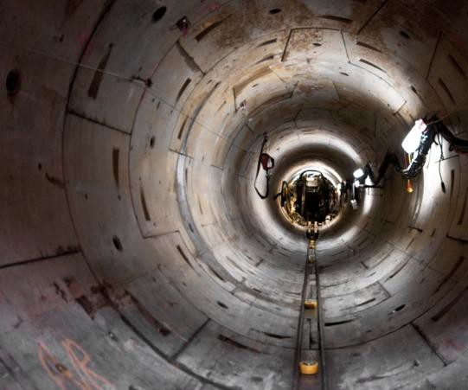  Sewerage pipe | 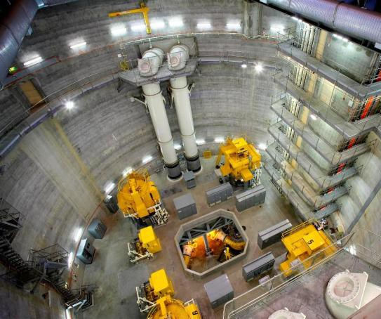  Pumping station

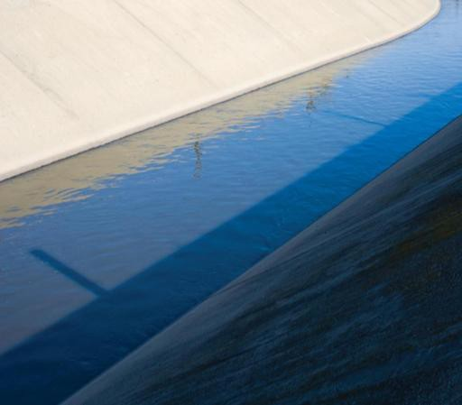  Western Treatment Plant channels | 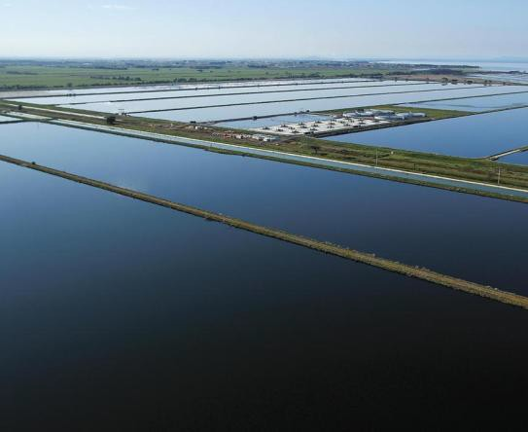  Western Treatment Plant lagoons
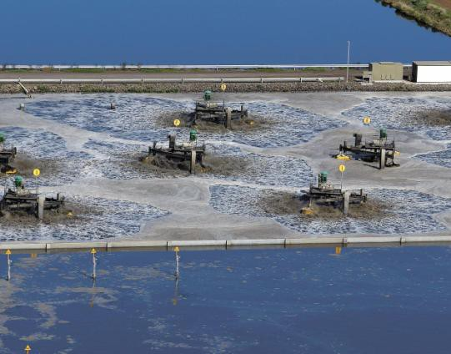  Western Treatment Plant aerators | 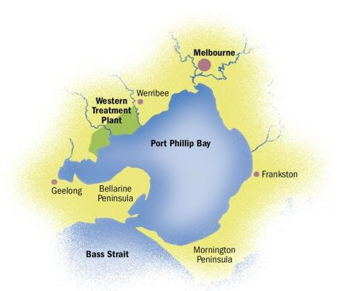  Sea (Port Phillip Bay)

Victorian Curriculum and Assessment Authority (VCAA) <http://victoriancurriculum.vcaa.vic.edu.au/> Accessed 14 August 2016.

